**Tableau Analysis for IMDB Database Design:**

**Overview:** Tableau is an Interactive [data visualization](https://en.wikipedia.org/wiki/Data_visualization) product focused on [Business intelligence](https://en.wikipedia.org/wiki/Business_intelligence) (BI).

We used Tableau to visualize and Analyze the data available in the newly created IMDB Database design.

In this scenario, we sampled the data available in the Database and tried to project the change or increase in IMDB user over the years. We grouped the IMDB registered user with the age group and projected them with the time line.

These analyses would help the IMDB organization to make a better attraction to the end user and improve their business with these analyses.

Data Considered for Analysis:

1. IMDB Registered General User Table
2. IMDB Registered User Profile Table.

Analysis based on:

1. Age – Calculated from the User’s Date of Birth.
2. Registered Year – Captured from the User’s Registration Date.

Tableau Work:

1. MS SQL Server Data base 2016 was used to communicate with the Tableau tool

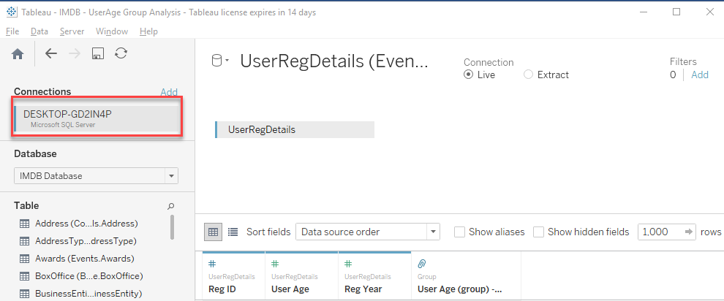

1. The Database designed in SQL Server was pulled into the tool.

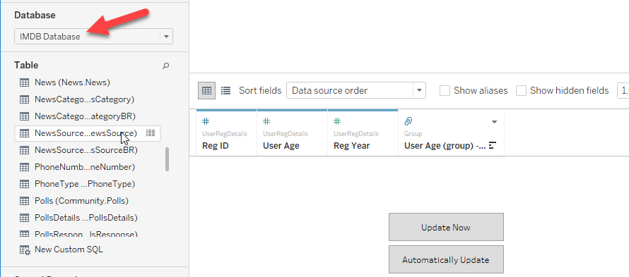

1. Table was identified for analysis (EVENTS.USERREGDETAILS)

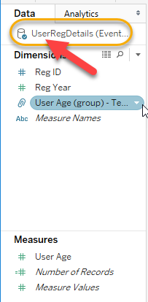

1. Columns and Rows to perform the analysis was made.

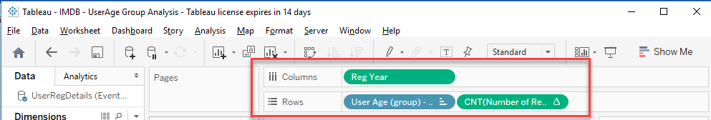

1. The User’s Age which are discrete quantities were grouped into respective groups (order of 5)

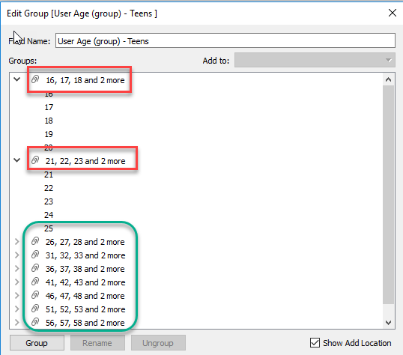

1. Then these data from the Database were extracted and made into an analysis graph as shown below.

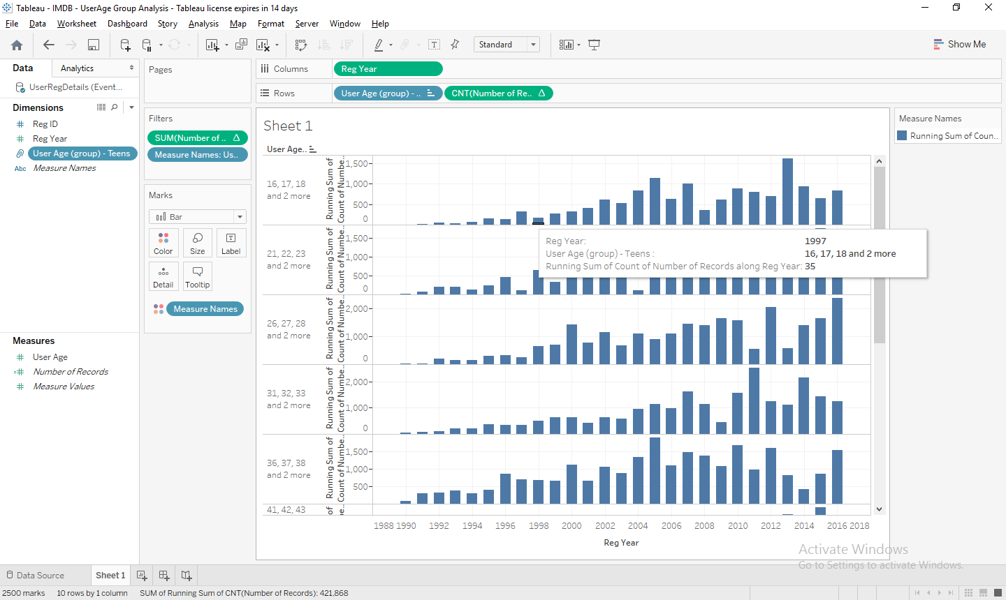

The Chart above shows the running total of the count of Registered IMDB user based on the age Group.

Full Image of the Tableau Report

